Spring Data JPA-Quick Example
MYSQL Commands:
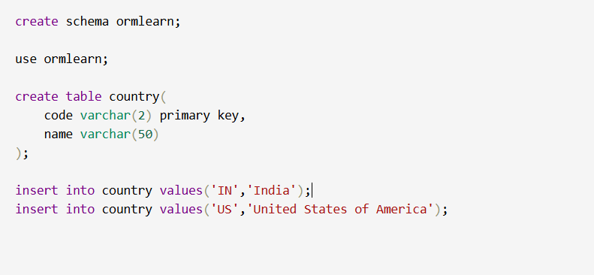
Application.properties:
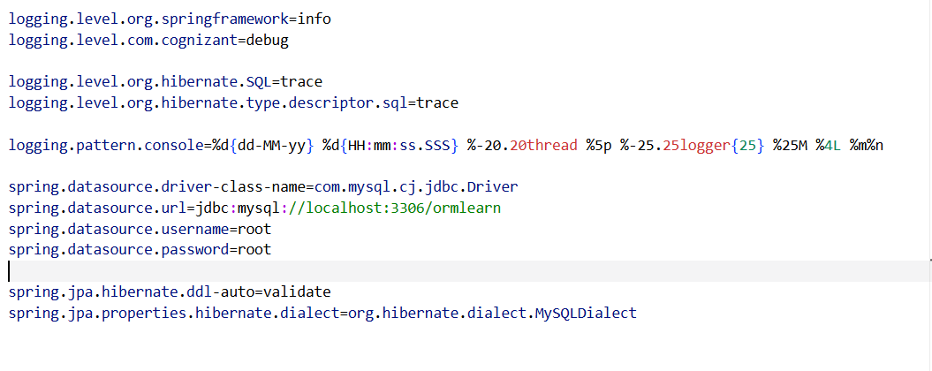
Country.java:
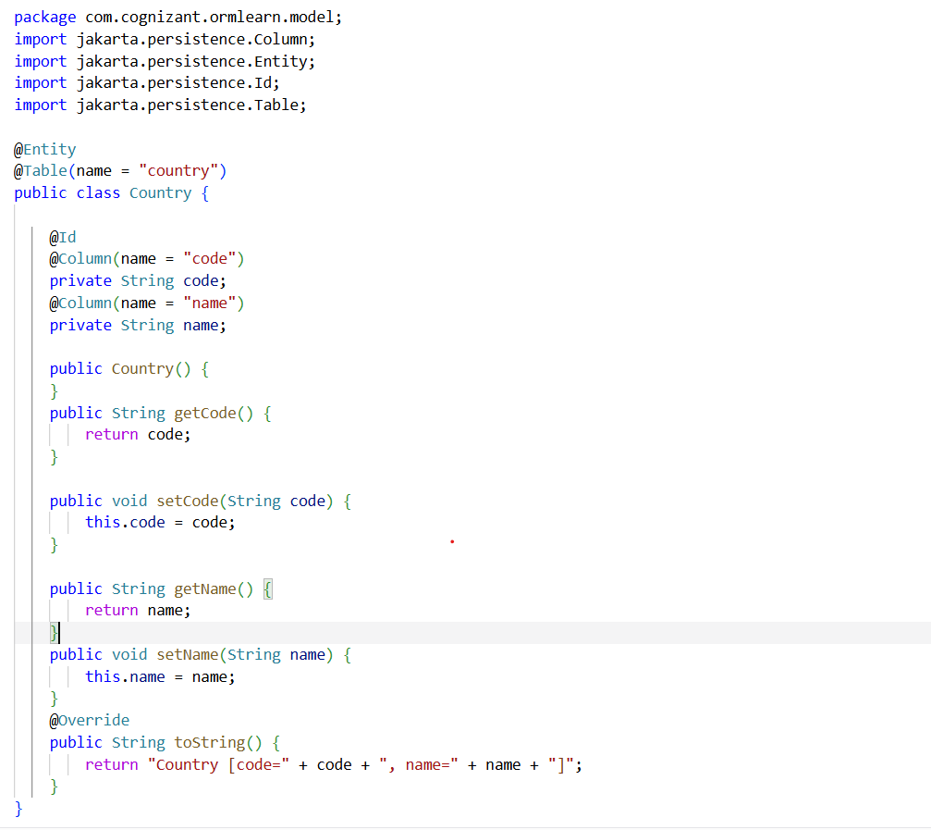
CountryRepository.java:
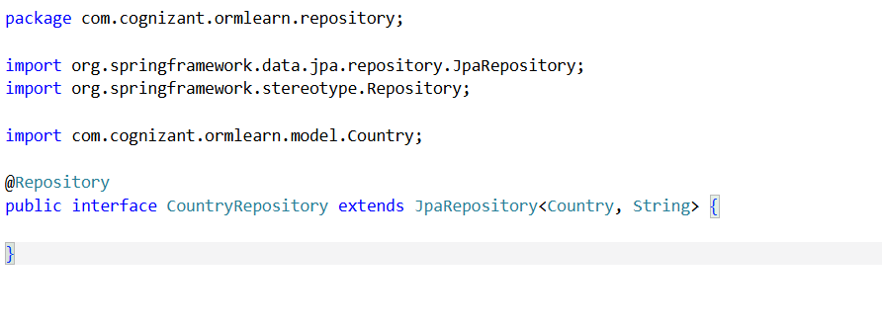
CountryService.java:
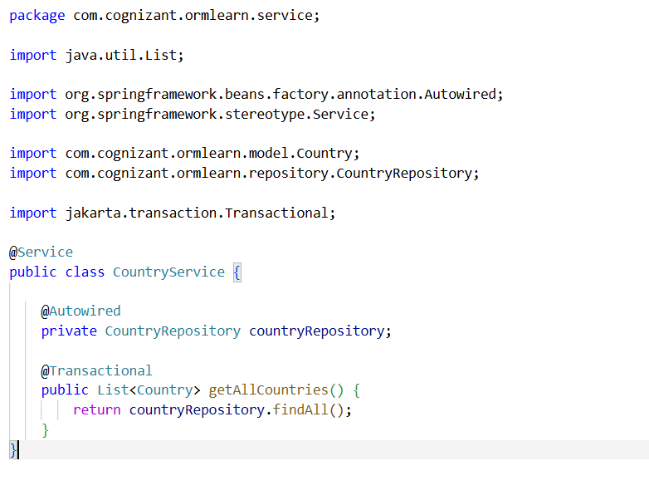
OrmLearnApplication.java:
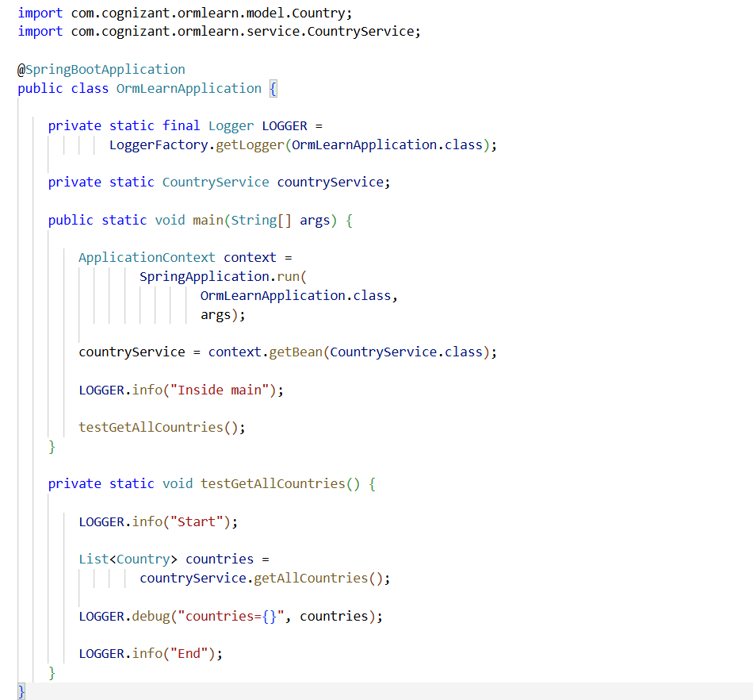
OUTPUT:
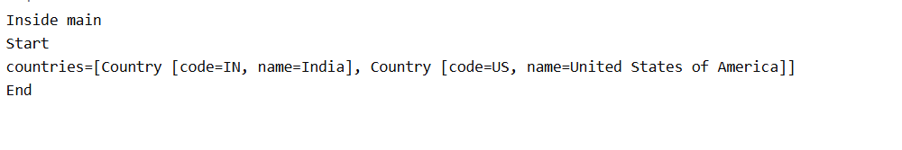

Difference between JPA,hibernate and Spring Data JPA
JPA:
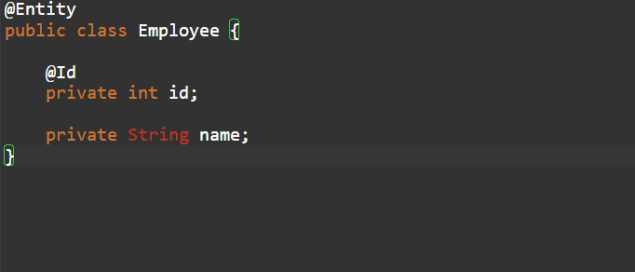
Hibernate:
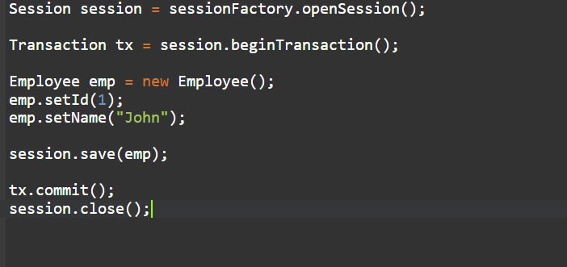
Spring Data JPA:
